
CBM Reading
Presentation Materials


Handouts 1–12
Case Studies 1–4
Appendix A: CBM Materials
Appendix B: CBM Resources
Contents
Handout 1: Letter Sound Fluency—Teacher Score Sheet 1
Handout 2: Letter Sound Fluency—Student Copy 2
Handout 3: Word Identification Fluency—Teacher Score Sheet 3
Handout 4: Word Identification Fluency—Student Copy 4
Handout 5: Passage Reading Fluency—Teacher Copy 5
Handout 6: Passage Reading Fluency—Student Copy 6
Handout 7: Passage Reading Fluency—Teacher Copy 7
Handout 8: Passage Reading Fluency—Student Copy 8
Handout 9: Maze Fluency—Student Copy, Page 1 9
Handout 10: Maze Fluency—Student Copy, Page 2 10
Handout 11: Practice Using the Tukey Method—Practice 1 11
Handout 12: Practice Using the Tukey Method—Practice 2 12
CBM Case Study #1: Sascha 13
CBM Case Study #2: Harrisburg Elementary 15
CBM Case Study #3: Ms. Wilson 19
CBM Case Study #4: Joshua 22
Appendix A: CBM Materials 24
Appendix B: CBM Resources 31

Handout 1: Letter Sound Fluency—Teacher Score Sheet
Teacher: I’m going to show you some letters. You can tell me what sound the letters make. You may know the sound for some letters. For other letters, you may now know the sounds. If you don’t know the sound a letter makes, don’t worry. Okay? What’s most important is that you try your best. I’ll show you how this activity works. My turn first. (Refer to the practice portion of the CBM LSF sheet.) This says /b/. Your turn now. What sound does it say?
Student: /b/
Examiner: Very good. You told me what sound the letter makes. (Correction procedures are provided in the CBM LSF manual.) You’re doing a really good job. Now it will be just your turn. Go as quickly and carefully as you can. Remember to tell me the sounds the letters make. Remember just try your best. If you don’t know the sounds it’s okay. Trigger the stopwatch.
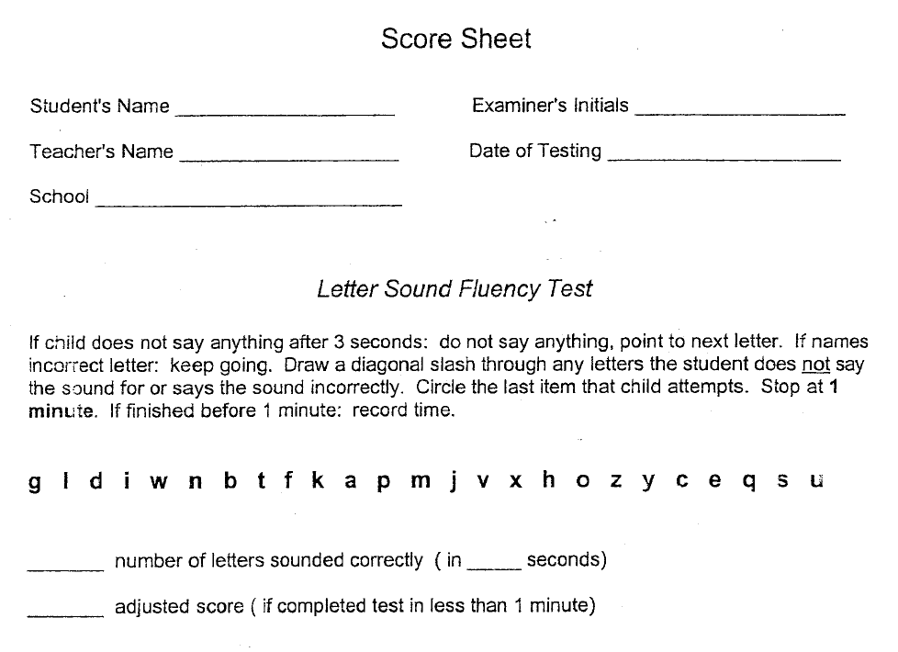

Handout 2: Letter Sound Fluency—Student Copy
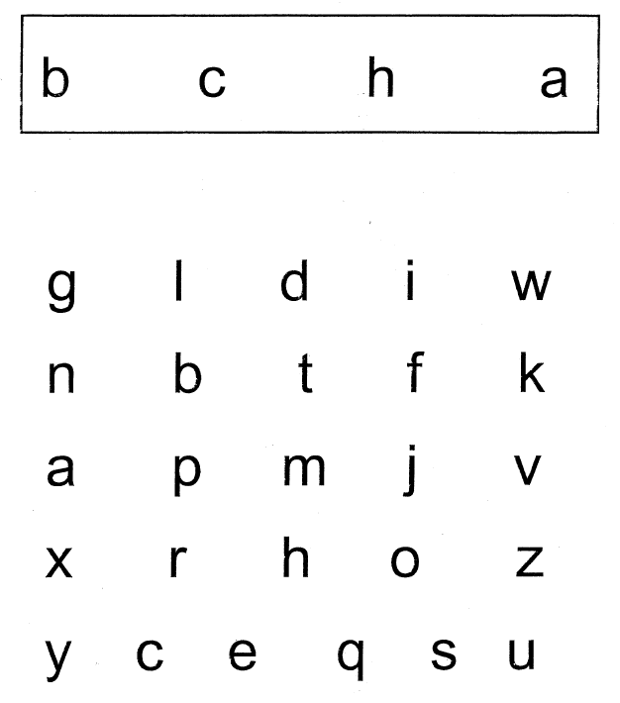

Handout 3: Word Identification Fluency—Teacher Score Sheet
Teacher: When I say, “Go,” I want you to read these words as quickly and correctly as you can. Start here (point to the first word) and go down the page (run your finger down the first column). If you don’t know a word, skip it and try the next word. Keep reading until I say stop. Do you have any questions? Trigger the stopwatch for 1 minute.
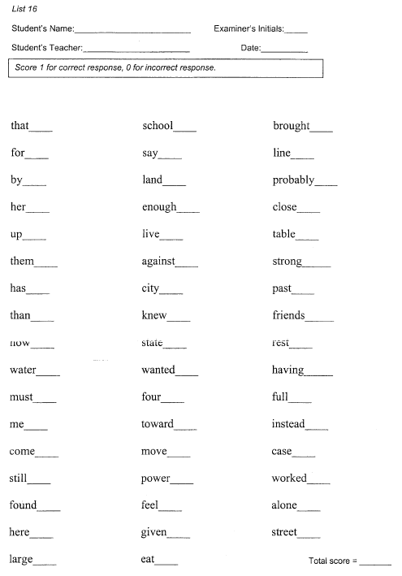

Handout 4: Word Identification Fluency—Student Copy
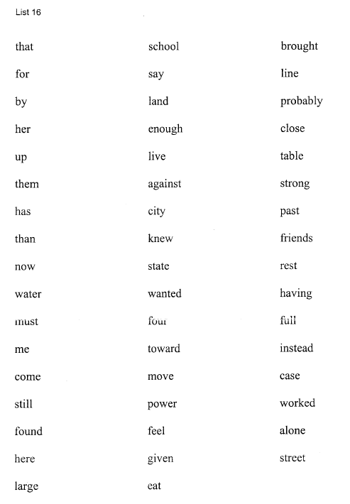

Handout 5: Passage Reading Fluency—Teacher Copy
It was raining outside, and there was nothing for Norman to do. 12
“I have the most boring life,” he moaned, as he plopped down on the couch. Just 28
as he switched on the television, the power went out. Watching a blank television 42
was not something Norman wanted to do. He looked around at the four dismal walls 57
that kept him out of the rain. 64
“Now what am I going to do?” 71
“You could tidy up your room,” his mom suggested, “or organize your closet. 84
Your closet is a disaster, Norman. I’m actually frightened of what you might find in 99
there. You haven’t cleaned it in a decade.” 107
There was nothing Norman could say after his mom had made up her mind. He 122
was going to have to clean out his closet. 131
The only problem was that Norman couldn’t even open his closet door. He had it 146
held closed with a large wooden block. There was so much junk in there that it 162
wouldn’t stay shut on its own. To push aside the wooden block and open the door 178
would mean doom for Norman. He’d be crushed by falling trash as soon as he 193
turned the knob. He decided that he would only pretend to clean his closet, but his 209
mother came into his bedroom. 214
“Well,” she said, placing her hands on her hips, “let’s see you get to work.” 229
Norman put both hands on the doorknob and tugged. The entire doorframe gave 242
a mighty CREAK. There was a loud rumble as Norman was pushed back by the 257
wave of forgotten junk he’d jammed into his closet. When the loud noise faded, 271
Norman was lying on his back under a mountain of broken toys, dirty socks, and 286
books. With a groan, he lifted himself to his feet. 296
There was an awful smell wafting from somewhere inside. Norman looked into 308
the depths of his closet. It was dark, dreary, and mysterious. Anything—absolutely 321
anything—could be hiding in there. Maybe trolls, ghouls, or gnomes, Norman 333
thought. This job could be an adventure! Pushing up his sleeves, Norman got to 347
work. 348

Licensed to University of Missouri It was raining Copyright 2001 Edformation, Inc.
For the 2003-2004 School Year Grade 5, Passage 10 All Rights Reserved
DN 290748

Handout 6: Passage Reading Fluency—Student Copy
It was raining outside, and there was nothing for Norman to do.
“I have the most boring life,” he moaned, as he plopped down on the couch. Just
as he switched on the television, the power went out. Watching a blank television
was not something Norman wanted to do. He looked around at the four dismal walls
that kept him out of the rain.
“Now what am I going to do?”
“You could tidy up your room,” his mom suggested, “or organize your closet.
Your closet is a disaster, Norman. I’m actually frightened of what you might find in
there. You haven’t cleaned it in a decade.”
There was nothing Norman could say after his mom had made up her mind. He
was going to have to clean out his closet.
The only problem was that Norman couldn’t even open his closet door. He had it
held closed with a large wooden block. There was so much junk in there that it
wouldn’t stay shut on its own. To push aside the wooden block and open the door
would mean doom for Norman. He’d be crushed by falling trash as soon as he
turned the knob. He decided that he would only pretend to clean his closet, but his
mother came into his bedroom.
“Well,” she said, placing her hands on her hips, “let’s see you get to work.”
Norman put both hands on the doorknob and tugged. The entire doorframe gave
a mighty CREAK. There was a loud rumble as Norman was pushed back by the
wave of forgotten junk he’d jammed into his closet. When the loud noise faded,
Norman was lying on his back under a mountain of broken toys, dirty socks, and
books. With a groan, he lifted himself to his feet.
There was an awful smell wafting from somewhere inside. Norman looked into
the depths of his closet. It was dark, dreary, and mysterious. Anything—absolutely
anything—could be hiding in there. Maybe trolls, ghouls, or gnomes, Norman
thought. This job could be an adventure! Pushing up his sleeves, Norman got to
work.

Licensed to University of Missouri It was raining Copyright 2001 Edformation, Inc.
For the 2003-2004 School Year Grade 5, Passage 10 All Rights Reserved
DN 290748

Handout 7: Passage Reading Fluency—Teacher Copy
An old man lived in a shack deep in the forest. His tiny shack stood 15
beside a musical brook. He didn't mind that his house was tiny or that 29
the wind blew in under his doors. Even though he was cramped and 42
often cold, he could listen to the music of the brook all day and night. 57
In his spare time, the old man made bells out of brass and silver. 71
However, the bells he made were silent. Only the musical brook beside 83
his shack could make the bells ring. Every evening the man would carry 96
the bells he'd forged that day to the brook and dip them into its musical 111
waters. The bells would go into the brook silent and come out ringing 124
with song. It always made the man joyful to hear his bells ringing. What 138
a beautiful sound! 141
New towns and villages were popping up all over the countryside, 152
so the man's bells were in high demand. People wanted his bells for 165
their clock towers and their churches. They wanted to hang his bells 177
above their doors and set them on the corners of their desks. 189
The bell-maker could have been a very rich man. Because his bells 202
rang more beautifully than any bells in the country, he could have set 215
any price for them. Instead, the man charged very little for his bells. In 229
fact, he gave many of his bells away for free. He gave entire octaves to 244
orphanages and hospitals. 247
The bell-maker was very happy. However, he was also getting old. 259
He could hardly lift the larger bells and carry them to the musical brook. 273
It was time for him to retire, but before he could retire, he needed to train 289
someone for his craft. 293
One evening a young man wandered up to his door. The bellmaker 305
recognized the young man. He knew the young man was once 317
rich and spoiled, but bad luck had stripped him of his fortune. The 330
young man was now humble and wise for all his toils. 341
"I need food," the young man told the bell-maker. 351
"Yes," the bell-maker replied. "But you need much more than that. 363
You need music, and I will help you." 371

Licensed to University of Missouri An old man Copyright 2001 Edformation, Inc.
For the 2003-2004 School Year Grade 4, Passage 7 All Rights Reserved
DN 290747

Handout 8: Passage Reading Fluency—Student Copy
An old man lived in a shack deep in the forest. His tiny shack stood
beside a musical brook. He didn't mind that his house was tiny or that
the wind blew in under his doors. Even though he was cramped and
often cold, he could listen to the music of the brook all day and night.
In his spare time, the old man made bells out of brass and silver.
However, the bells he made were silent. Only the musical brook beside
his shack could make the bells ring. Every evening the man would carry
the bells he'd forged that day to the brook and dip them into its musical
waters. The bells would go into the brook silent and come out ringing
with song. It always made the man joyful to hear his bells ringing. What
a beautiful sound!
New towns and villages were popping up all over the countryside,
so the man's bells were in high demand. People wanted his bells for
their clock towers and their churches. They wanted to hang his bells
above their doors and set them on the corners of their desks.
The bell-maker could have been a very rich man. Because his bells
rang more beautifully than any bells in the country, he could have set
any price for them. Instead, the man charged very little for his bells. In
fact, he gave many of his bells away for free. He gave entire octaves to
orphanages and hospitals.
The bell-maker was very happy. However, he was also getting old.
He could hardly lift the larger bells and carry them to the musical brook.
It was time for him to retire, but before he could retire, he needed to train
someone for his craft.
One evening a young man wandered up to his door. The bellmaker
recognized the young man. He knew the young man was once
rich and spoiled, but bad luck had stripped him of his fortune. The
young man was now humble and wise for all his toils.
"I need food," the young man told the bell-maker.
"Yes," the bell-maker replied. "But you need much more than that.
You need music, and I will help you."

Licensed to University of Missouri An old man Copyright 2001 Edformation, Inc.
For the 2003-2004 School Year Grade 4, Passage 7 All Rights Reserved
DN 290747

Handout 9: Maze Fluency—Student Copy, Page 1
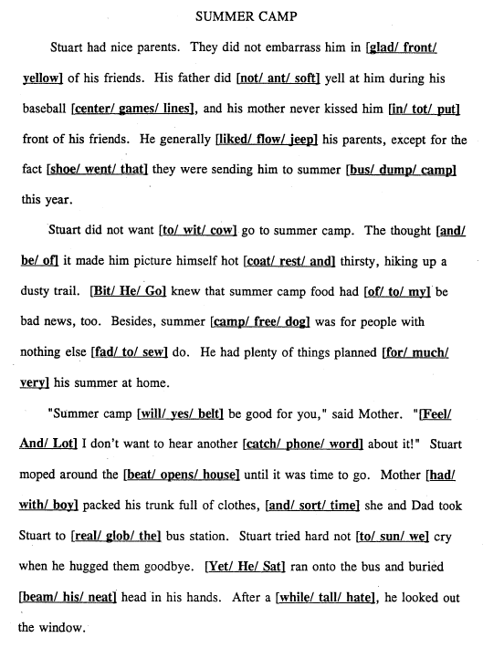

Handout 10: Maze Fluency—Student Copy, Page 2
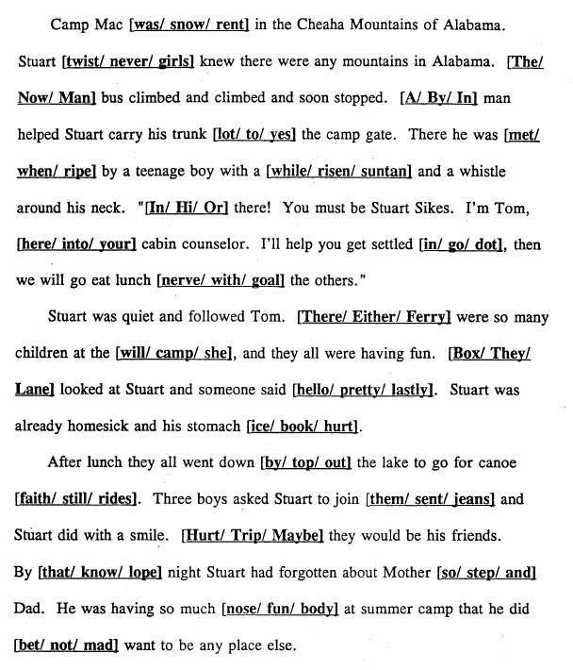

Handout 11: Practice Using the Tukey Method—Practice 1
WIF: Correctly Read Words Per Minute | 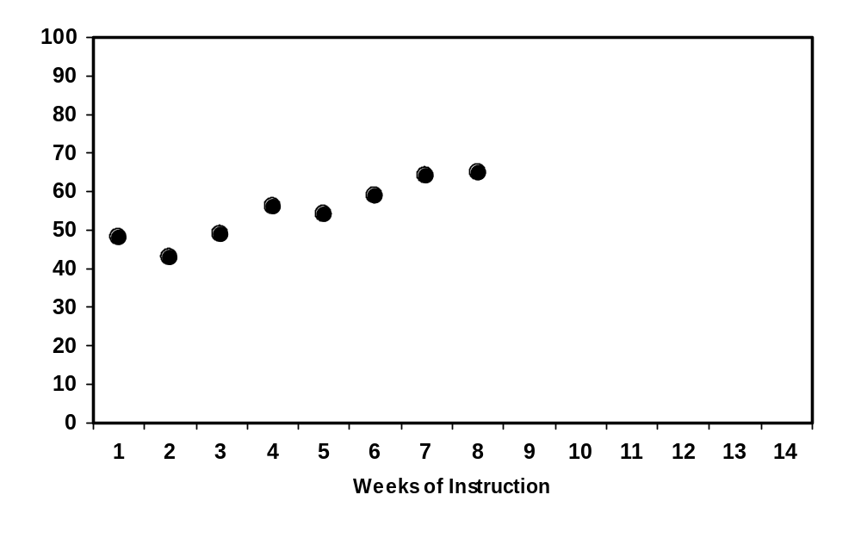
Step 1: Divide the data points into three equal sections by drawing two vertical lines. (If the points divide unevenly, group them approximately).

Step 2: In the first and third sections, find the median data-point and median instructional week. Locate the place on the graph where the two values intersect and mark with an “X”.

Step 3: Draw a line through the two “X’s”, extending to the margins of the graph. This represents the trend-line or line of improvement.

(Hutton, Dubes, & Muir, 1992)

Handout 12: Practice Using the Tukey Method—Practice 2
WIF: Correctly Read Words Per Minute | 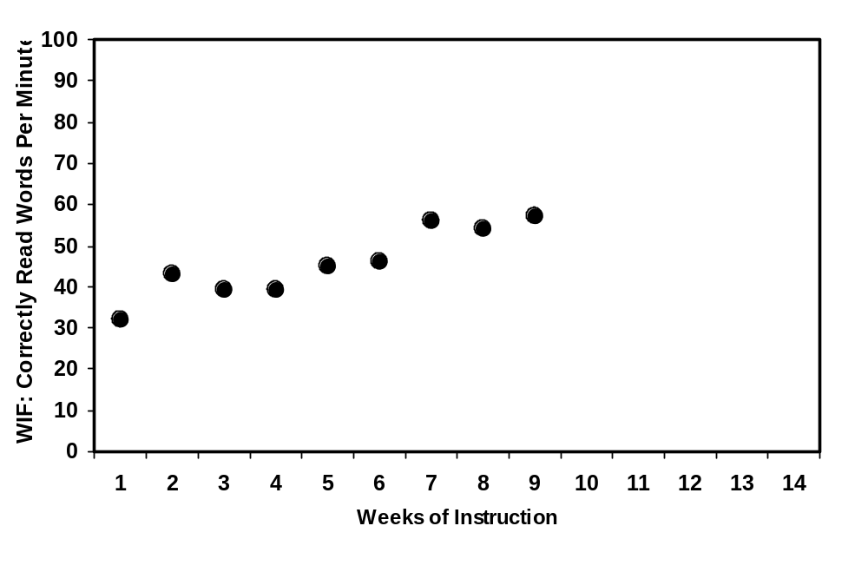

Step 1: Divide the data points into three equal sections by drawing two vertical lines. (If the points divide unevenly, group them approximately).

Step 2: In the first and third sections, find the median data-point and median instructional week. Locate the place on the graph where the two values intersect and mark with an “X”.

Step 3: Draw a line through the two “X’s”, extending to the margins of the graph. This represents the trend-line or line of improvement.

(Hutton, Dubes, & Muir, 1992)

CBM Case Study #1: Sascha
Mr. Miller has been monitoring his entire class using weekly CBM Passage Reading Fluency tests. He has been graphing student scores on individual student graphs. Mr. Miller used the Tukey method to draw a trend-line for Sascha’s CBM PRF scores. This is Sascha’s graph.
0
20
40
60
80
100
120
140
160
180
200
1
2
3
4
5
6
7
8
9
10
11
12
13
14
Weeks of Instruction

X

X

Sascha’s
trend
-
line

Sascha’s
goal-line
Correctly Read Words Per Minute
X

Since Sascha’s trend-line is flatter than her goal-line, Mr. Miller needs to make a change to Sascha’s instructional program. He has marked the week of the instructional change with a dotted vertical line. To decide what type of instructional change might benefit Sascha, Mr. Miller decides to do a Quick Miscue Analysis on Sascha’s weekly CBM PRF to find her strengths and weaknesses as a reader.
The following is Sascha’s CBM PRF test.
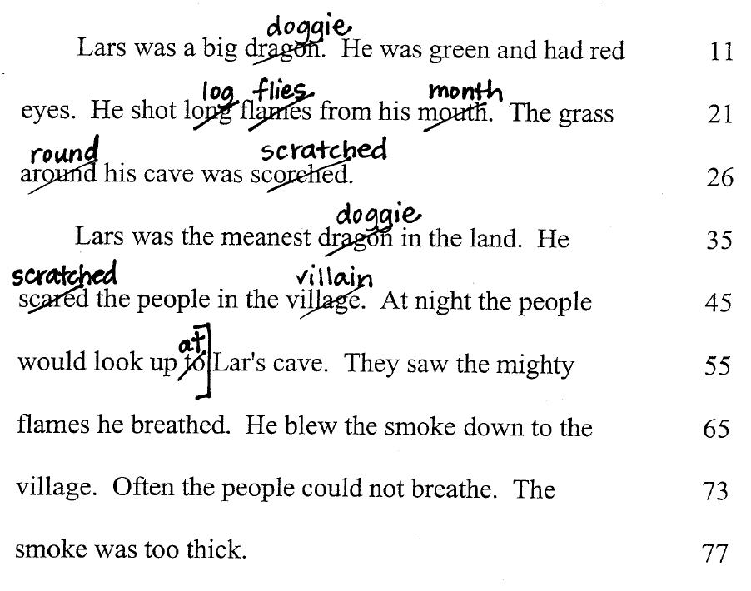

This is Sascha’s Quick Miscue Analysis for her CBM PRF test.
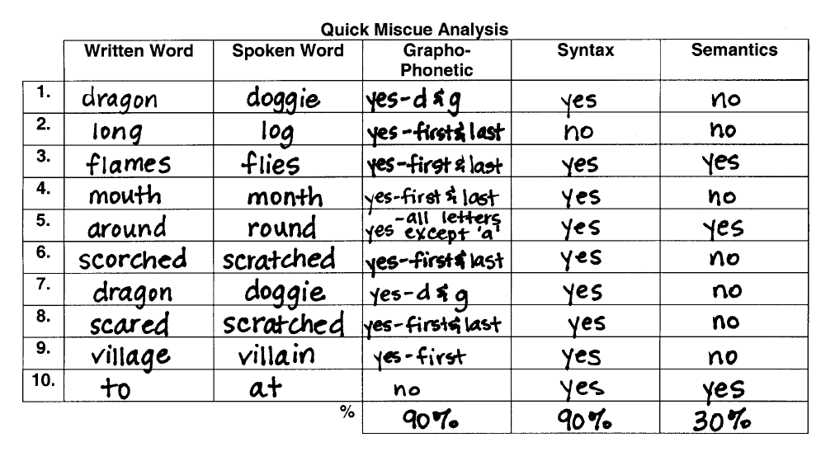

Based on the Quick Miscue Analysis Table, what instructional program changes should Mr. Miller introduce into Sascha’s reading program?

CBM Case Study #2: Harrisburg Elementary
Dr. Eckstein is the principal of Harrisburg Elementary School. She has decided, along with the school teachers and district administration, to use CBM to monitor progress towards reaching Adequate Yearly Progress (AYP) towards their school’s “No Child Left Behind” proficiency goal.
Last school year (2002-2003), all 378 students at the school were assessed using CBM PRF at the appropriate grade level. 125 students initially met CBM benchmarks, and so 125 represents Harrisburg’s initial proficiency status. The discrepancy between initial proficiency and universal proficiency is 253 students. To find the number of students who must meet CBM benchmarks each year before the 2113-2114 deadline, the discrepancy of 253 students is divided by the number of years until the deadline (11). 253 ÷ 11 = 23. 23 students need to meet CBM benchmarks each year in order for the school to demonstrate AYP.
During the 2003-2004 school year, Dr. Eckstein is provided with these CBM graphs based on the performance of the students in her school.
Based on this graph, what can Dr. Eckstein decide about her school’s progress since the initial year of benchmarks?
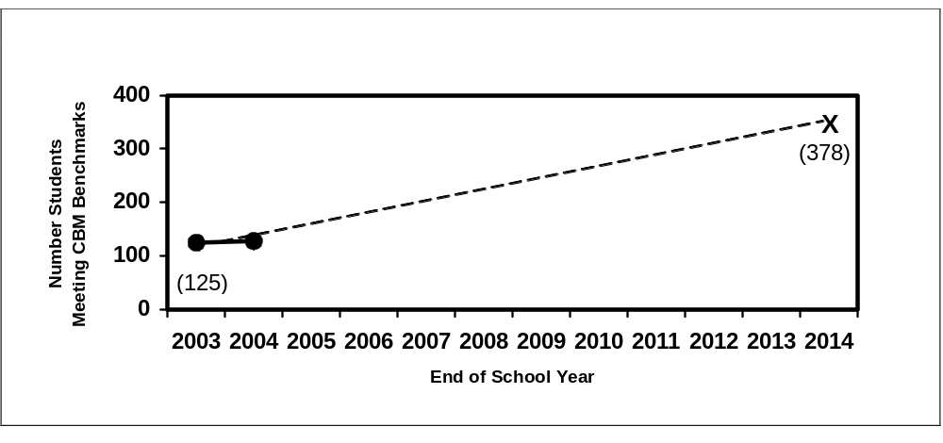

Based on this graph, what can Dr. Eckstein decide about her school’s progress since the beginning of the school year?
0
50
100
150
200
Sept
Oct
Nov
Dec
Jan
Feb
Mar
Apr
May
June
2004 School-Year Month
Number Students
Meeting CBM Benchmarks

X

(148)

Dr. Eckstein receives the next two graphs from two different second-grade teachers.
What information can she gather from these graphs?
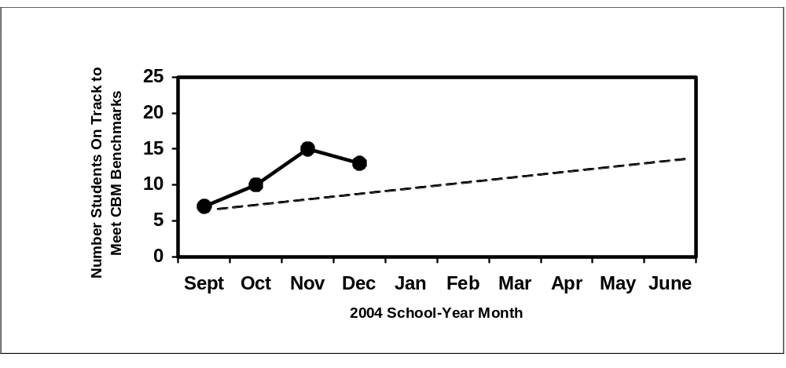

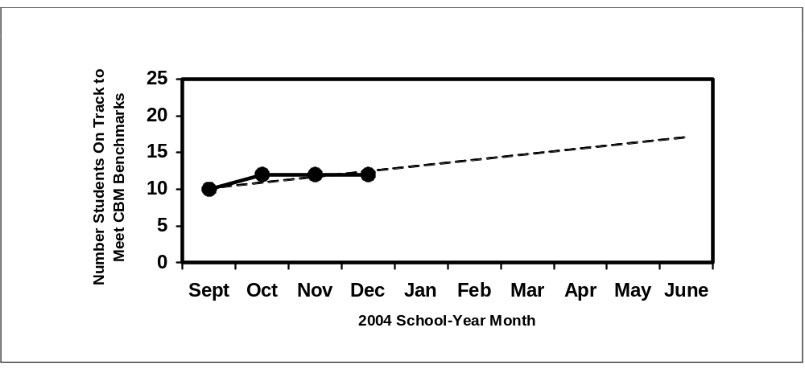

This is the graph that Dr. Eckstein receives based on the performance of Harrisburg’s Special Education students. What should she learn from this graph?
Figure 54: Harrisburg Elementary – Within-Year Special Education Progress
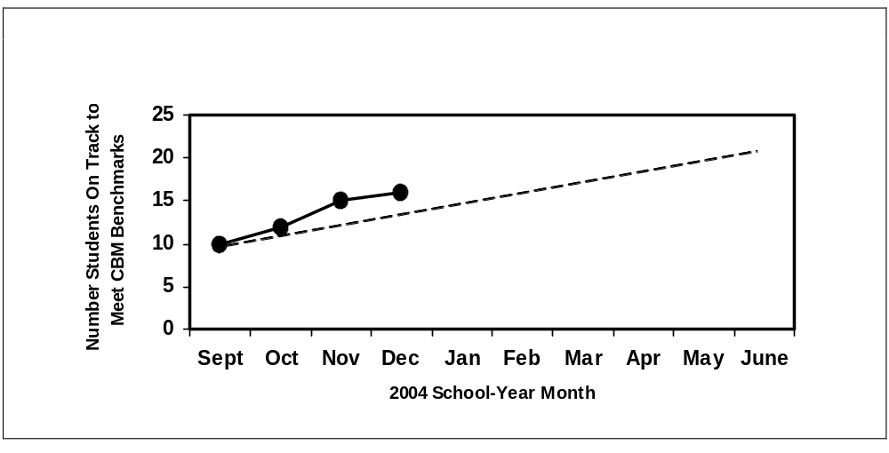
Dr. Eckstein receives a graph for every student in the school. She gives these graphs to the respective teachers of each student. How can the teachers use the graphs?
0
20
40
60
80
100
Sept
Oct
Nov
Dec
Jan
Feb
Mar
Apr
May
June
2004 School-Year Month
CBM Score: Grade 1
Word Identification Fluency

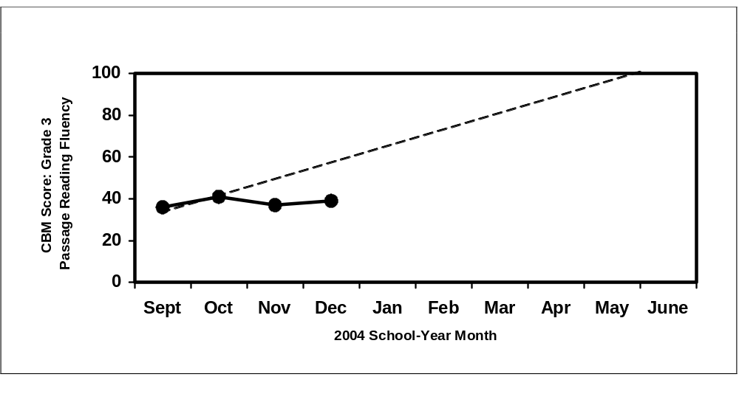

CBM Case Study #3: Ms. Wilson
Mrs. Wilson has conducted CBM since the beginning of the school year with all of the students in her classroom. She has received the following printout from the progress monitoring computer software program.
This is the first page of Mrs. Wilson’s CBM Class Report. How would you characterize how her class is doing? How can she use this information to improve the reading of the students in her classroom?

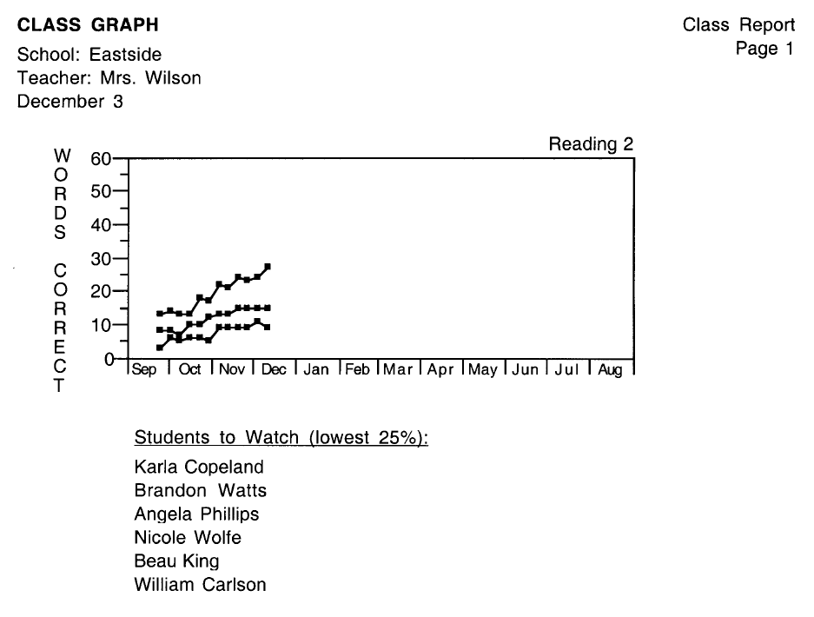
This is the second page of Mrs. Wilson’s Class Report. How can she use this class report to improve her classroom instruction?
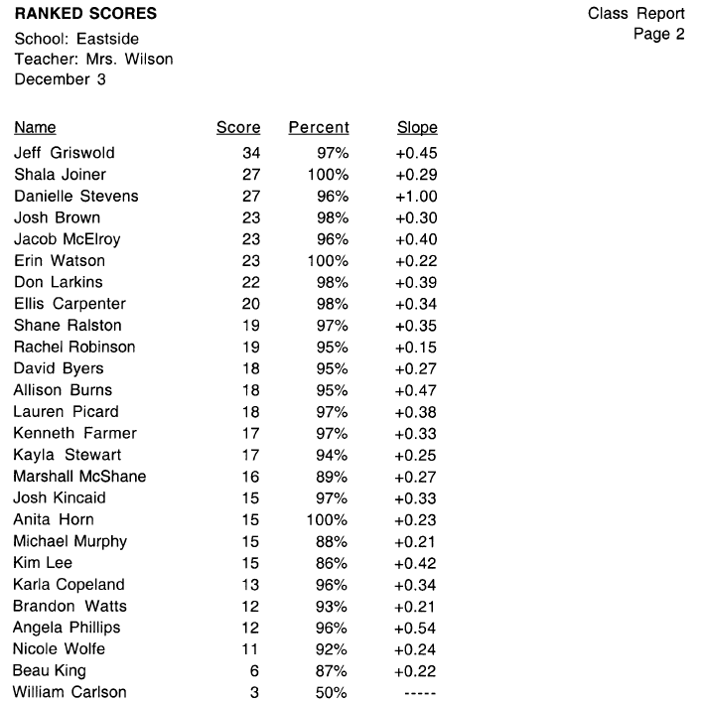

This is the third page of Mrs. Wilson’s Class Report. What information does she learn on this page? How can she use this information?
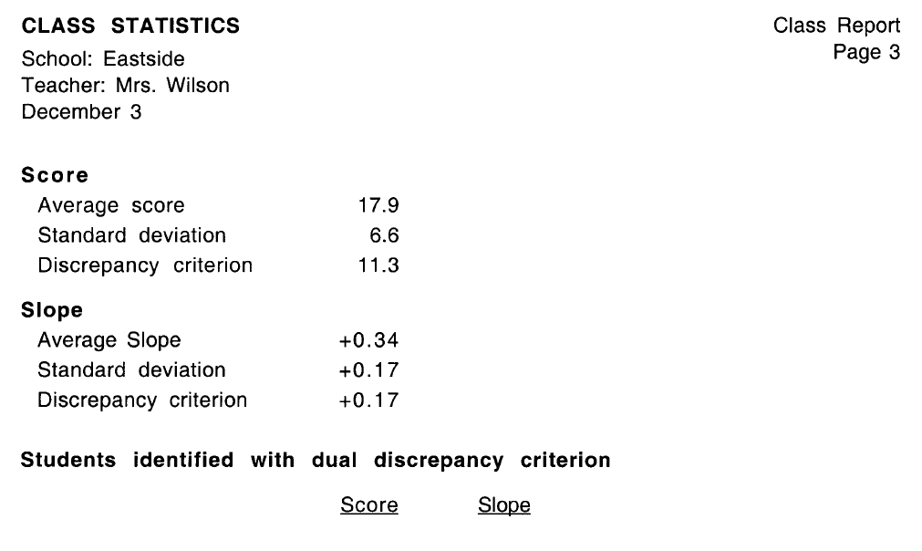

CBM Case Study #4: Joshua
Mrs. Sanchez has been using CBM to monitor the progress of all of the students in her classroom for the entire school year. She has one student, Joshua, who has been performing extremely below his classroom peers, even after two instructional changes.
Look at Joshua’s CBM graph.
PRF: Words Read Correctly Per Minute | 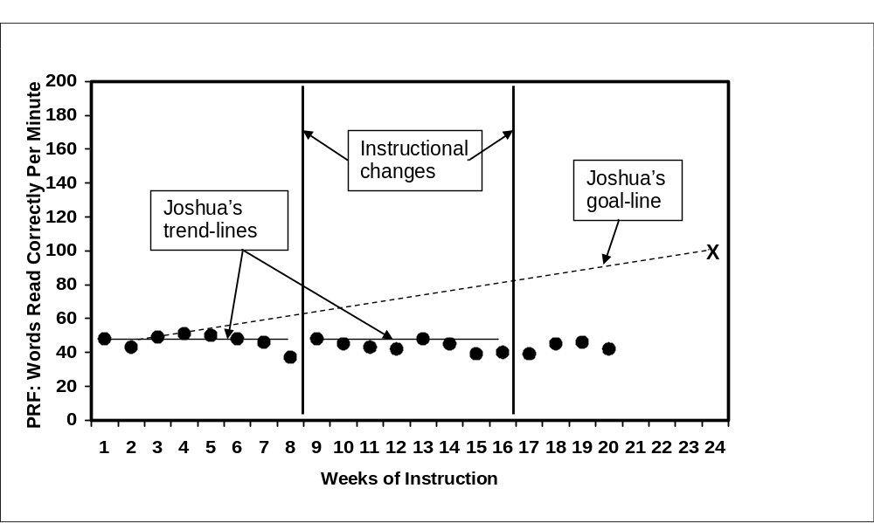

After eight weeks, Mrs. Sanchez determined that Joshua’s trend-line was flatter than his goal-line, so she made an instructional change to Joshua’s reading program. This instructional change included having Joshua work on basic sight words that he was trying to sound out when reading. The instructional change is the first thick, vertical line on Joshua’s graph.
After another eight weeks, Mrs. Sanchez realized that Joshua’s trend-line was still flatter than his goal-line. His graph showed that Joshua had made no improvement in reading. So, Mrs. Sanchez made another instructional change to Joshua’s reading program. This instructional change included having Joshua work on basic letter sounds and how those letter sounds combine to form words. The second instructional change is the second thick, vertical line on Joshua’s graph.
Mrs. Sanchez has been conducting CBM for 20 weeks and still has yet to see any improvement with Joshua’s reading despite two instructional teaching changes. What could this graph tell Mrs. Sanchez about Joshua? Pretend you’re at a meeting with your principal and IEP team members, what would you say to describe Joshua’s situation? What would you recommend as the next steps? How could Mrs. Sanchez use this class graph to help her with her decisions about Joshua?
PRF: Words Read Correctly Per Minute | 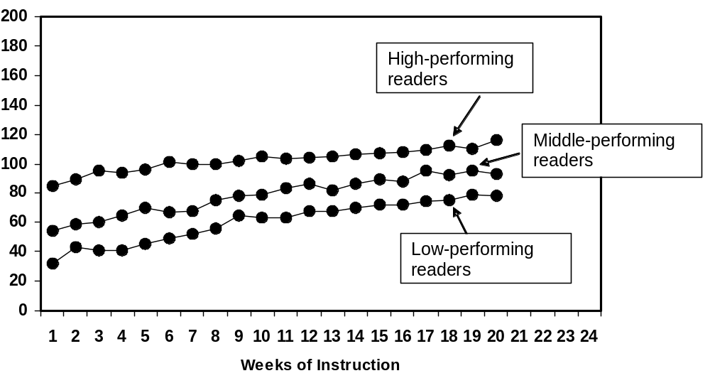

Appendix A: CBM Materials
The various CBM reading measures and computer software may be obtained from the following sources.
AIMSweb / Edformation (CBM reading passages and computer software)
AIMSweb is based on CBM. It provides materials for CBM data collection and supports data use.
The following reading measures are available:
- Standard Benchmark Reading Assessment Passages:
  - 3 graded and equivalent passages for grades 1-8 for establishing fall, winter, and spring benchmarks
  - (24 total passages)
  - also available in Spanish
- Standard Progress Monitoring Reading Assessment Passages:
  - 30 graded and equivalent passages for grades 2-8
  - 23 graded and equivalent passages for grade 1
  - 23 graded and equivalent passages for primer level
  - (256 passages total)
- Standard Benchmark Early Literacy Assessment Measures:
  - 3 equivalent Standard Benchmark Early Literacy Measures to assess Phonemic Awareness and Phonics for kindergarten and grade 1 for establishing fall, winter, and spring benchmarks
- Standard Progress Monitoring Early Literacy Measures:
  - 30 equivalent Standard Early Literacy Measures for kindergarten and grade 1
  - (30 tests for each indicator)
- Standard Benchmark Reading Maze Passages:
  - 3 Standard Assessment Reading Passages for grades 1-8 have been prepared in a maze (multiple choice close) format to use as another measure of reading comprehension
  - (24 maze passages total)
- Standard Progress Monitoring Reading Maze Passages:
  - 30 graded and equivalent passages prepared in maze format for grades 2-8
  - 23 graded and equivalent passages prepared in maze format for grade 1
  - 23 graded and equivalent passages prepared in maze format for pre-primer level
  - (256 passages total)
The following are provided with the passages:
- Administration and Scoring Directions
- Directions for Organizing and Implementing a Benchmark Assessment Program
AIMSweb also has a progress monitoring computer software program available for purchase. Once the teacher administers and scores the CBM tests, the scores can be entered into the computer program for automatic graphing and analysis.
Sample AIMSweb Report
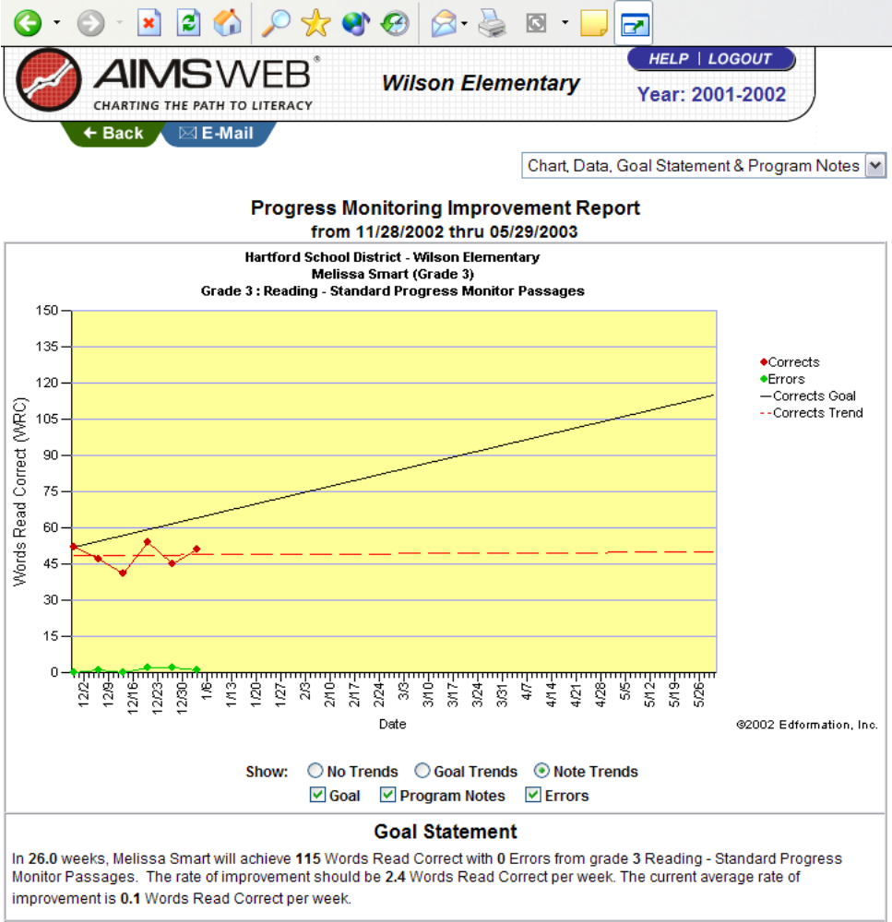

AIMSweb measures, administration guides, scoring guides, and software are available for purchase on the internet:
http://www.aimsweb.com or http://www.edformation.com
Phone: 888-944-1882
Mail: Edformation, Inc.
6420 Flying Cloud Drive, Suite 204
Eden Prairie, MN 55344
DIBELS (CBM reading passages and computer assistance)
Dynamic Indicators of Basic Early Literacy Skills (DIBELS) are a set of standardized, individually administered measures of early literacy development. They are designed to be short (one minute) fluency measures used to regularly monitor the development of pre-reading and early reading skills. DIBELS measures are free to download and use. To obtain the measures, teachers must register on the DIBELS website.
The following reading measures are available:
- Phoneme Segmentation Fluency (kindergarten)
- Benchmark reading passages for grades 1-6 (9 per grade)
- Assessment reading passages for grades 1-6 (20 per grade)
- Benchmark and Assessment reading passages also available in Spanish
DIBELS also operates a DIBELS Data System that allows teachers to enter students’ scores, once the teacher has administered and scored the tests, online to generate automated reports. The cost for this service is $1 per student, per year.
Sample DIBELS Report
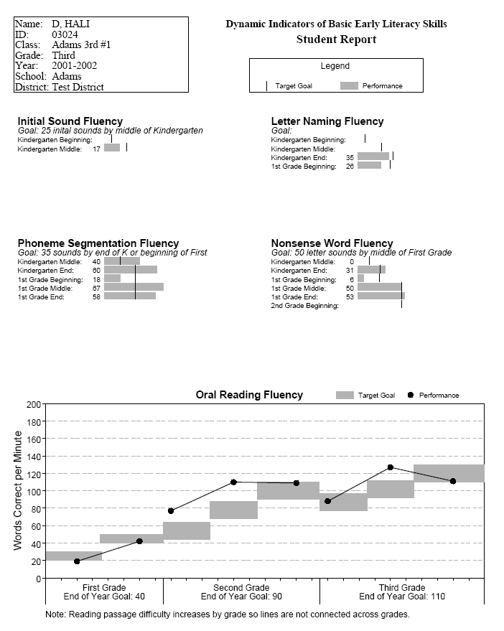

DIBELS measures, administration guides, scoring guides, and information on the automated Data System are on the internet:
http://dibels.uoregon.edu/
Edcheckup (CBM reading passages)
Edcheckup offers an assessment system for screening student performance and measuring student progress toward goals in reading, based on the CBM model. The assessment system administers and scores student tests via computer.
The following reading passages are available:
- 138 Oral Reading passages for grades 1-6
- 138 Maze Reading passages for grades 1-6
- 23 Letter Sounds reading probes
- 23 Isolated Words reading probes
The following computer assistance is available:
- Student data and scores are entered on-line.
- Reports and graphs are automatically generated that follow class and student progress.
- Guidelines for setting annual goals and evaluating student progress are provided.
Edcheckup reading passages are available for purchase on the internet:
http://www.edcheckup.com
Phone: 952-229-1440
Mail: WebEdCo
7701 York Avenue South – Suite 250
Edina, MN 55435
McGraw-Hill (CBM computer software)
Yearly ProgressPro™, from McGraw-Hill Digital Learning, combines ongoing formative assessment, prescriptive instruction, and a reporting and data management system to give teachers and administrators the tools they need to raise student achievement. Yearly ProgressPro™ is a computer-administered progress monitoring and instructional system to bring the power of Curriculum Based Measurement (CBM) into the classroom. Students take tests on the computer, eliminating teacher time in administration and scoring.
Weekly 15-minute diagnostic CBM assessments provide teachers with the information they need to plan classroom instruction and meet individual student needs. Ongoing assessment across the entire curriculum allows teachers to measure the effectiveness of instruction as it takes place and track both mastery and retention of grade level skills. Yearly ProgressPro™ reports allow teachers and administrators to track progress against state and national standards at the individual student, class, building, or district level. Administrators can track progress towards AYP goals and disaggregate date demographically to meet NCLB requirements.
Sample Yearly ProgressPro™ Student Report
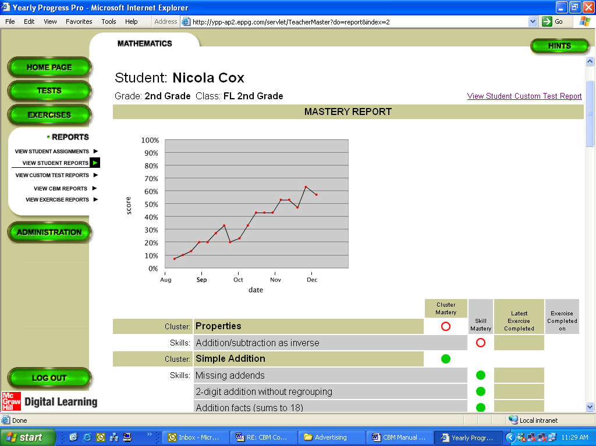

Information on the McGraw-Hill computer software is available on the internet:
http://www.mhdigitallearning.com
Phone: 1-800-848-1567 ext. 4928
Vanderbilt University (CBM reading passages)
CBM materials were developed and researched using standard CBM procedures.
The following reading passages are available:
- Letter Sound Fluency Test for kindergarten (5 tests)
- Word Identification Fluency Test for grade 1 (20 tests)
- CBM Reading passages for grades 1-8 (30 passages per grade)
- Maze Fluency passages for grades 1-6 (30 passages per grade)
The CBM measures are free, except for copying costs, postage, and handling. The CBM measures, scoring sheets, administration instructions, and scoring instructions are available:
Phone: 615-343-4782
Email: flora.murray@vanderbilt.edu
Mail: Flora Murray
Peabody #328
230 Appleton Place
Nashville, TN 37203-5721

Appendix B: CBM Resources
Deno, S. L. (1985). Curriculum-based measurement: The emerging alternative. Exceptional Children, 52, 219-232.
Deno, S. L., Fuchs, L. S., Marston, D., & Shin, J. (2001). Using curriculum-based measurement to establish growth standards for students with learning disabilities. School Psychology Review, 30, 507–524.
Deno, S. L., & Mirkin, P. K. (1977). Data-based program modification: A manual. Reston, VA: Council for Exceptional Children.
Fuchs, L. S. (1987). Curriculum-based measurement for instructional program development. Teaching Exceptional Children, 20, 42–44.
Fuchs, L. S., & Deno, S. L. (1987). Developing curriculum-based measurement systems for data-based special education problem solving. Focus on Exceptional Children, 19, 1–16.
Fuchs, L. S., & Deno, S. L. (1991). Paradigmatic distinctions between instructionally relevant measurement models. Exceptional Children, 57, 488–501.
Fuchs, L. S., & Deno, S. L. (1994). Must instructionally useful performance assessment be based in the curriculum? Exceptional Children, 61, 15–24.
Fuchs, L. S., Deno, S. L., & Mirkin, P. K. (1984). Effects of frequent curriculum-based measurement of evaluation on pedagogy, student achievement, and student awareness of learning. American Educational Research Journal, 21, 449–460.
Fuchs, L. S., & Fuchs, D. (1990). Curriculum-based assessment. In C. Reynolds & R. Kamphaus (Eds.), Handbook of psychological and educational assessment of children (Vol. 1): Intelligence and achievement. New York: Guilford Press.
Fuchs, L. S., & Fuchs, D. (1992). Identifying a measure for monitoring student reading progress. School Psychology Review, 58, 45–58.
Fuchs, L. S., & Fuchs, D. (1996). Combining performance assessment and curriculum-based measurement to strengthen instructional planning. Learning Disabilities Research and Practice, 11, 183–192.
Fuchs, L. S., & Fuchs, D. (1998). Treatment validity: A unifying concept for reconceptualizing the identification of learning disabilities. Learning Disabilities Research and Practice, 13, 204–219.
Fuchs, L. S., & Fuchs, D. (1999). Monitoring student progress toward the development of reading competence: A review of three forms of classroom-based assessment. School Psychology Review, 28, 659–671.
Fuchs, L. S., & Fuchs, D. (2000). Curriculum-based measurement and performance assessment. In E. S. Shapiro & T. R. Kratochwill (Eds.), Behavioral assessment in schools: Theory, research, and clinical foundations (2nd ed., pp. 168–201). New York: Guilford.
Fuchs, L. S., & Fuchs, D. (2002). Curriculum-based measurement: Describing competence, enhancing outcomes, evaluating treatment effects, and identifying treatment nonresponders. Peabody Journal of Education, 77, 64–84.
Fuchs, L. S., & Fuchs, D. (in press). Determining Adequate Yearly Progress from kindergarten through grade 6 with curriculum-based measurement. Assessment for Effective Instruction.
Fuchs, L. S., Fuchs, D., & Hamlett, C. L. (1989a). Effects of alternative goal structures within curriculum-based measurement. Exceptional Children, 55, 429–438.
Fuchs, L. S., Fuchs, D., & Hamlett, C. L. (1989b). Effects of instrumental use of curriculum-based measurement to enhance instructional programs. Remedial and Special Education, 10, 43–52.
Fuchs, L. S., Fuchs, D., & Hamlett, C. L. (1990). Curriculum-based measurement: A standardized long-term goal approach to monitoring student progress. Academic Therapy, 25, 615–632.
Fuchs, L. S., Fuchs, D., & Hamlett, C. L. (1993). Technological advances linking the assessment of students’ academic proficiency to instructional planning. Journal of Special Education Technology, 12, 49–62.
Fuchs, L. S., Fuchs, D., & Hamlett, C. L. (1994). Strengthening the connection between assessment and instructional planning with expert systems. Exceptional Children, 61, 138–146.
Fuchs, L. S., Fuchs, D., & Hamlett, C. L. (in press). Using technology to facilitate and enhance curriculum-based measurement. In K. Higgins, R. Boone, & D. Edyburn (Eds.), The Handbook of special education technology research and practice. Whitefish Bay, WI: Knowledge by Design, Inc.
Fuchs, L. S., Fuchs, D., Hamlett, C. L., Phillips, N. B., & Karns, K. (1995). General educators’ specialized adaptation for students with learning disabilities. Exceptional Children, 61, 440–459.
Fuchs, L. S., Fuchs, D., Hamlett, C. L., Phillips, N. B., Karns, K., & Dutka, S. (1997). Enhancing students’ helping behavior during peer-mediated instruction with conceptual mathematical explanations. Elementary School Journal, 97, 223–250.
Fuchs, L. S., Fuchs, D., Hamlett, C. L., & Stecker, P. M. (1991). Effects of curriculum-based measurement and consultation on teacher planning and student achievement in mathematics operations. American Educational Research Journal, 28, 617–641.
Fuchs, L. S., Fuchs, D., Hamlett, C. L., Thompson, A., Roberts, P. H., Kubek, P., & Stecker, P. S. (1994). Technical features of a mathematics concepts and applications curriculum-based measurement system. Diagnostique, 19, 23–49.
Fuchs, L. S., Fuchs, D., Hamlett, C. L, Walz, L., & Germann, G. (1993). Formative evaluation of academic progress: How much growth can we expect? School Psychology Review, 22, 27–48.
Fuchs, L. S., Fuchs, D., Hosp, M., & Hamlett, C. L. (2003). The potential for diagnostic analysis within curriculum-based measurement. Assessment for Effective Intervention, 28, 13–22.
Fuchs, L. S., Fuchs, D., Hosp, M. K., & Jenkins, J. R. (2001). Oral reading fluency as an indicator of reading competence: A theoretical, empirical, and historical analysis. Scientific Studies of Reading, 5, 241–258.
Fuchs, L. S., Fuchs, D., Karns, K., Hamlett, C. L., Dutka, S., & Katzaroff, M. (2000). The importance of providing background information on the structure and scoring of performance assessments. Applied Measurement in Education, 13, 83–121.
Fuchs, L. S., Fuchs, D., Karns, K., Hamlett, C. L., & Katzaroff, M. (1999). Mathematics performance assessment in the classroom: Effects on teacher planning and student learning. American Educational Research Journal, 36, 609–646.
Fuchs, L. S., Fuchs, D., Karns, K., Hamlett, C. L., Katzaroff, M., & Dutka, S. (1997). Effects of task-focused goals on low-achieving students with and without learning disabilities. American Educational Research Journal, 34, 513–544.
Fuchs, D., Roberts, P. H., Fuchs, L. S., & Bowers, J. (1996). Reintegrating students with learning disabilities into the mainstream: A two-year study. Learning Disabilities Research and Practice, 11, 214–229.
Germann G., & Tindal, G. (1985). An application on curriculum-based assessment: The use of direct and repeated measurement. Exceptional Children, 52, 244–265.
Gersten, R., & Dimino, J. A. (2001). The realities of translating research into classroom practice. Learning Disabilities Research and Practice, 16, 120–130.
Gickling, E. E. (1981). The forgotten learner. Nevada Public Affairs Review, 1, 19–22.
Hutton, J. B., Dubes, R., & Muir, S. (1992). Estimating trend progress in monitoring data: A comparison of simple line-fitting methods. School Psychology Review, 21, 300–312.
Jenkins, J. R., Mayhall, W., Peshka, C., & Townshend, V. (1974). Using direct and daily measures to measure learning. Journal of Learning Disabilities, 10, 604–608.
Marston, D., Mirkin, P. K., & Deno, S. L. (1984). Curriculum-based measurement: An alternative to traditional screening, referral, and identification of learning disabilities of learning disabled students. The Journal of Special Education, 18, 109–118.
Marston, D. (1988). The effectiveness of special education: A time-series analysis of reading performance in regular and special education settings. The Journal of Special Education, 21, 13–26.
Phillips, N. B., Hamlett, C. L., Fuchs, L. S., & Fuchs, D. (1993). Combining classwide curriculum-based measurement and peer tutoring to help general educators provide adaptive education. Learning Disabilities Research and Practice, 8, 148–156.
Shinn, M. R. (Ed.). (1989). Curriculum-based measurement: Assessing special children. New York: Guilford Press.
Shinn, M. R., Tindal, G. A., & Stein, S. (1988). Curriculum-based measurement and the identification of mildly handicapped students: A research review. Professional School Psychology, 3, 69–86.
Stecker, P. M., & Fuchs, L. S. (2000). Effecting superior achievement using curriculum-based measurement: The importance of individual progress monitoring. Learning Disabilities Research and Practice, 15, 128–134.
Tindal, G., Wesson, C., Germann, G., Deno, S., & Mirkin, P. (1982). A data-based special education delivery system: The Pine County Model. (Monograph No. 19). Minneapolis, MN: University of Minnesota, Institute for Research on Learning Disabilities.
Tucker, J. (1987). Curriculum-based assessment is not a fad. The Collaborative Educator, 1, 4, 10.
Wesson, C., Deno, S. L., Mirkin, P. K., Sevcik, B., Skiba, R., King, P. P., Tindal, G. A., & Maruyama, G. (1988). A causal analysis of the relationships among outgoing measurement and evaluation, structure of instruction, and student achievement. The Journal of Special Education, 22, 330–343.
Zeno, S. M., Ivens, S. H., Millard, R. T., & Duvvuri, R. (1995). The educator's word frequency guide.
New York, NY: Touchstone Applied Science Associates, Inc.

